Temperature Sending Unit

A common problem with our C1s is a faulty or improperly reading water temperature gauge. You know the problem – the gauge reads that the car is overheating, but all indications are that the temperature is actually normal. While you can have a bad gauge, the problem is normally associated with the sending unit screwed into the manifold water passage.

The current GM replacement sender is available (GM p/n 12334869). It replaced the original GM sender (p/n 1513321) and while it looks right it does not provide the proper resistance to the water temperature gauge circuit.

A common quick fix is to add a resistor in series with the sender, with a little experimentation you can get the gauge to read correctly – however, the gauge will read correctly only at the one temperature where the resistance is exactly correct for the gauge.

To verify that the problem is the sender and not the gauge, you need to remove the sender from the car and suspend it in a pan of water on the stove. Use a cooking thermometer to monitor the actual temperature of the water as you raise the temperature. As the water heats up, using an ohmmeter you can read the resistance from the center connection of the sender to the outside brass portion of the sender (where the threads are). A properly operating sender should indicate resistance readings very similar to these:

220 degrees = 70 ohms
200 degrees = 90 ohms
160 degrees = 140 ohms
120 degrees = 250 ohms
100 degrees = 340 ohms
68 degrees = 638 ohms

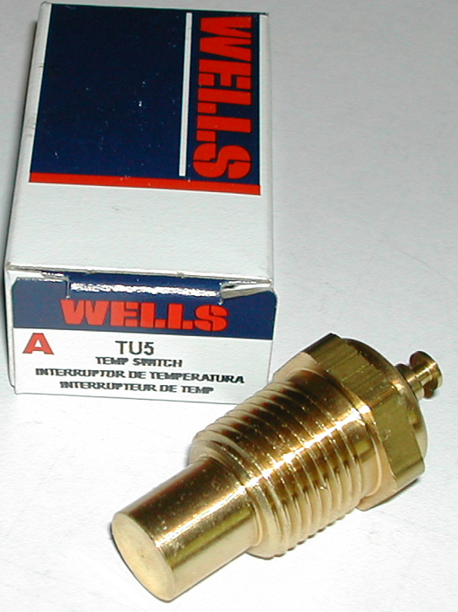
Some of the parts houses are advertising that they have the right sender in stock – perhaps they do. However, to save yourself some trouble, make a quick trip to you local “Auto Zone” parts store and while there buy a Wells TU-5 sending unit – they are about $6 and seem to be just exactly the right thing.

Oh, and when you reinstall the sender – I’ve heard that you should not use any Teflon tape or sealant between the sender and the manifold – you should have metal to metal contact between the manifold and the sender. I’m not certain whether that is actually true; however, it makes sense to me as the sender is nothing more than a variable resistor completing a path to ground. If you insulate the brass housing of the sender from the manifold – then the path to ground will be disrupted and you won’t achieve the proper resistance in the circuit.

